ALUMNI

Sir Chhotu Ram Government College For Women, Sampla has a registered Alumni Association and office bearers of the Alumni Association comprised of 11 members as follows:

Dr. Minakshi, Assistant Professor of Mathematics working as President
Ms. Savita Hooda, Assistant Professor of Hindi as Vice President
Dr. Indu Bala, Extension Lecturer of Hindi contributing as Secretary
Ms. Mamta, Assistant Professor of Commerce as Treasurer.

The main objective of the Association is to bridge the gap between the college and alumni. Alumni association meetings take place yearly to discuss future plans. Along with the association meeting, annual alumni meet is also organized at the institute level every year. Annual Alumni Meetings bring a rich interaction between old and younger generations which also upholds our cherished customs and traditions. Alumni contribution happens in various non-financial forms such as alumni interaction with students and motivating them. This enhances the student's experience and gives the competitive edge in today’s tough job market. Some of the alumni are actively participating in social service combining with creative activities for the welfare of society and they also motivate students to follow their path for the betterment of society.

Glimpses of Alumni Meet 2021-22

A formal function which consists of the inauguration, alumni interaction with students, Walk-in Campus along with Photography followed by Lunch. The office-bearers of the Alumni Association are very active and working effectively for the betterment of students. The Alumni Association has successfully conducted the annual alumni meet on 03.12.20221.

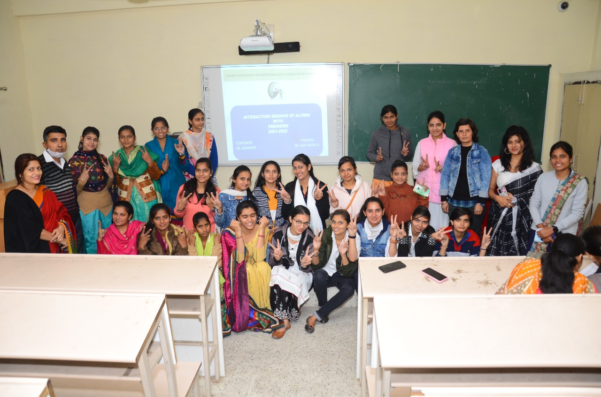

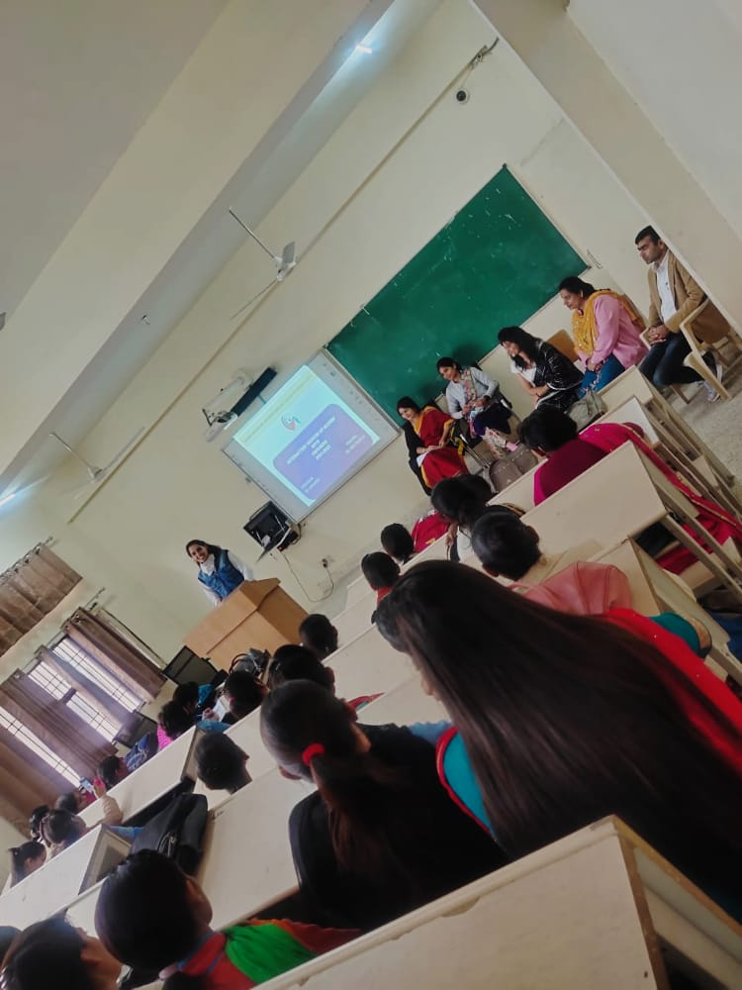

Distinguished Alumni of College:

- Mrs. Pooja: Chairman of Municipal Committee, Sampla
- Dr. Indu: Working as Extension Lecturer Hindi in this college.

