**Registration letter of Ms Madhu**

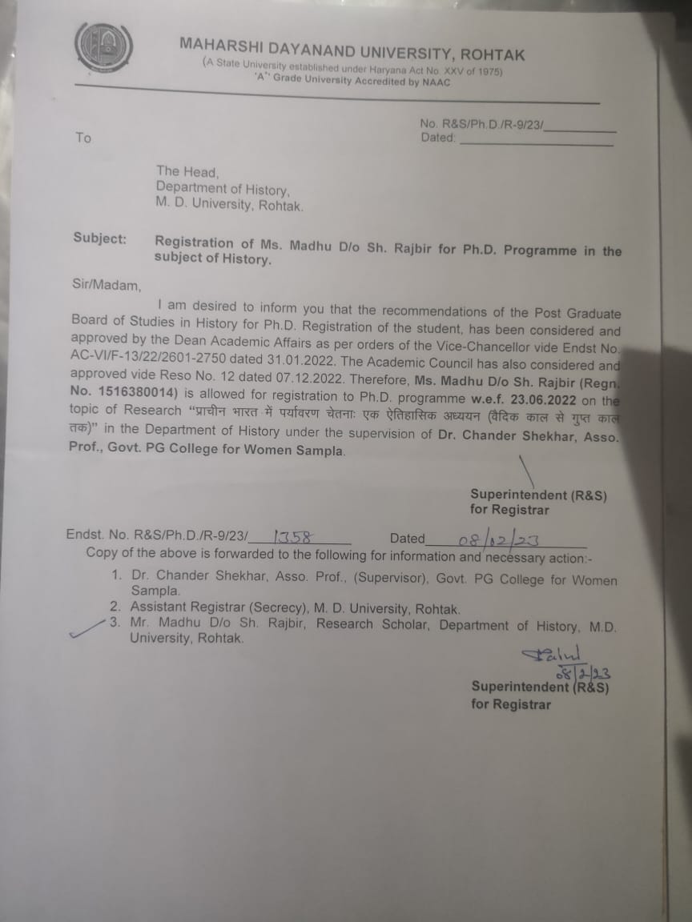

**Registration letter Mr Monu**

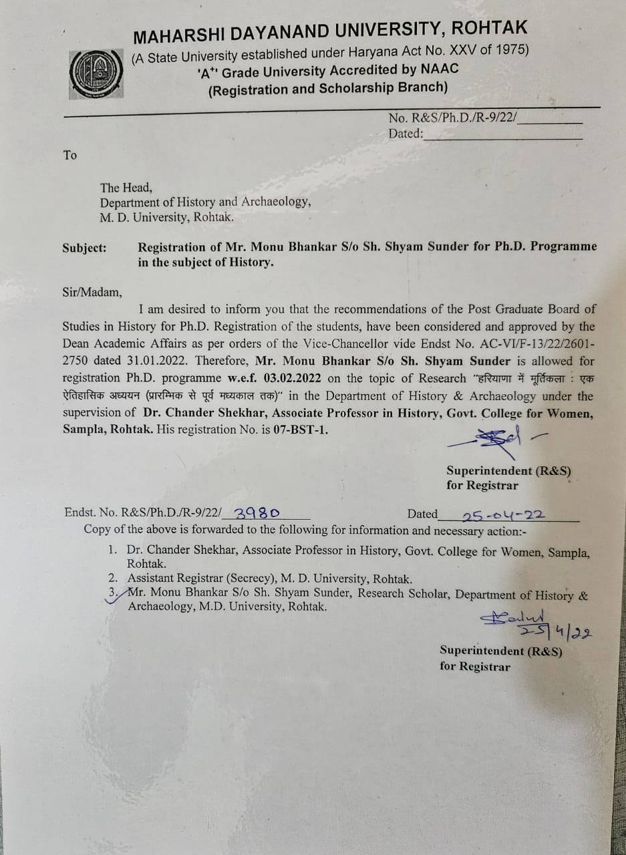

**Registration letter Mr Ayush**

