**Best Practices 2022-23**

**Practice 1:**

**Title of Practice:** Saving youth from drug addiction

**Objective:** To spread awareness about ill effects of substance abuse among the youth.

**Context:** The entire world is facing the problem of trapping of youth in drug addiction. So, it is our duty to aware the masses by providing preventive education on substance abuse starting from the college and then going from door to door, village to village and nearby localities.

**Practice:** The College is moving towards its aim to build up Swasth, Shasakt and Sajag yuva.

**Evidence of success:** The college has made efforts to spread awareness about substance abuse through extension lectures, various competitions viz. poster making, quiz, slogan writing, essay writing etc. organized by different cells/committees of the college.

**Problems encountered and resources required:**

Youth is greatly influenced by social media, unemployment and stress.

2. The government should control the negative impact of social media on youth.

<https://mail.google.com/mail/u/0?ui=2&ik=c0c1051ad6&attid=0.1&permmsgid=msg-a:r6051042886772035559&th=18c78f3c002c1c12&view=att&disp=safe&realattid=18c78f3b29228ad4f9d1>

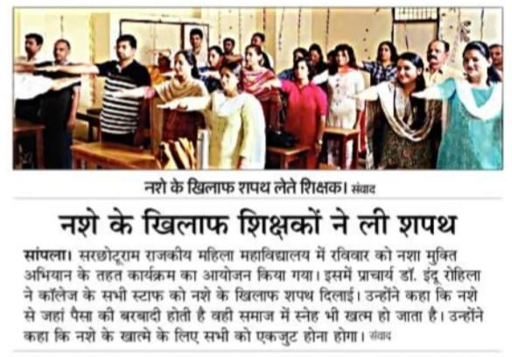

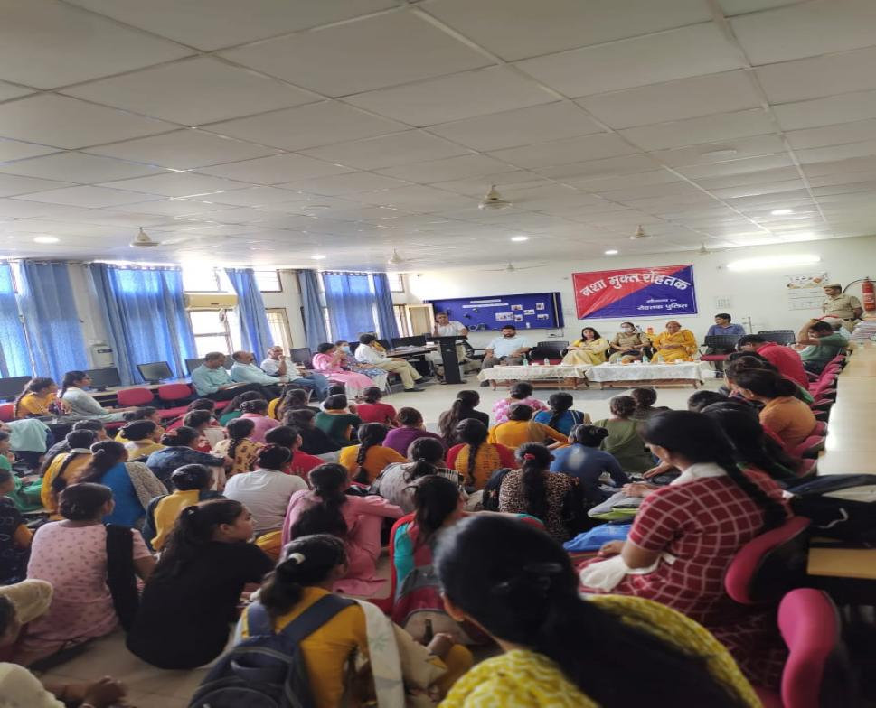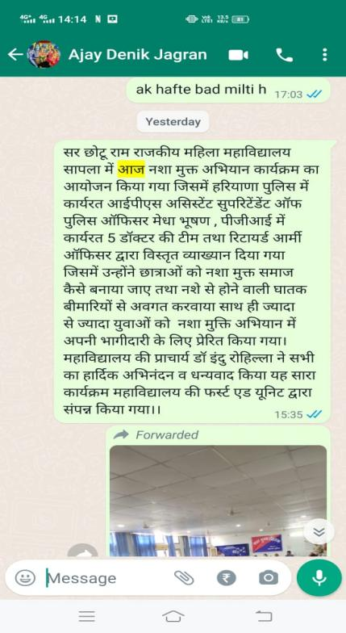

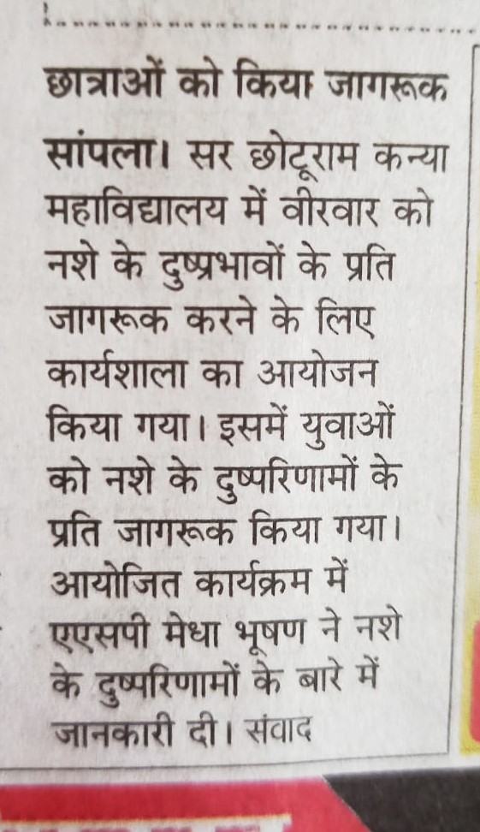

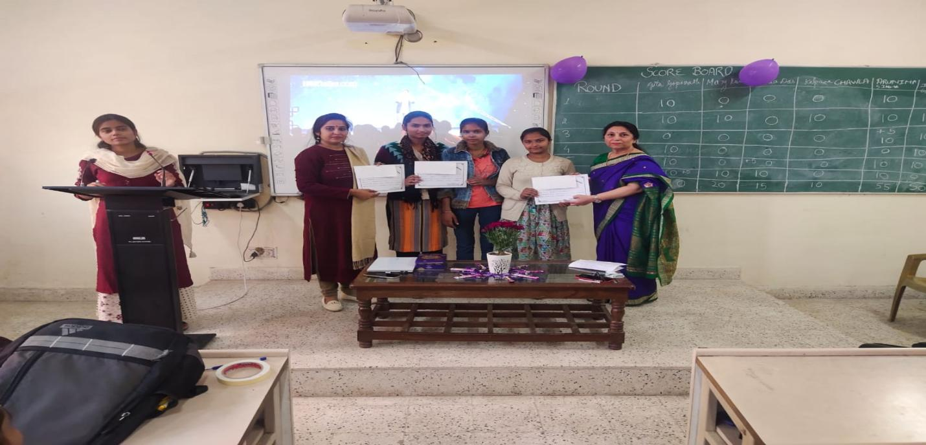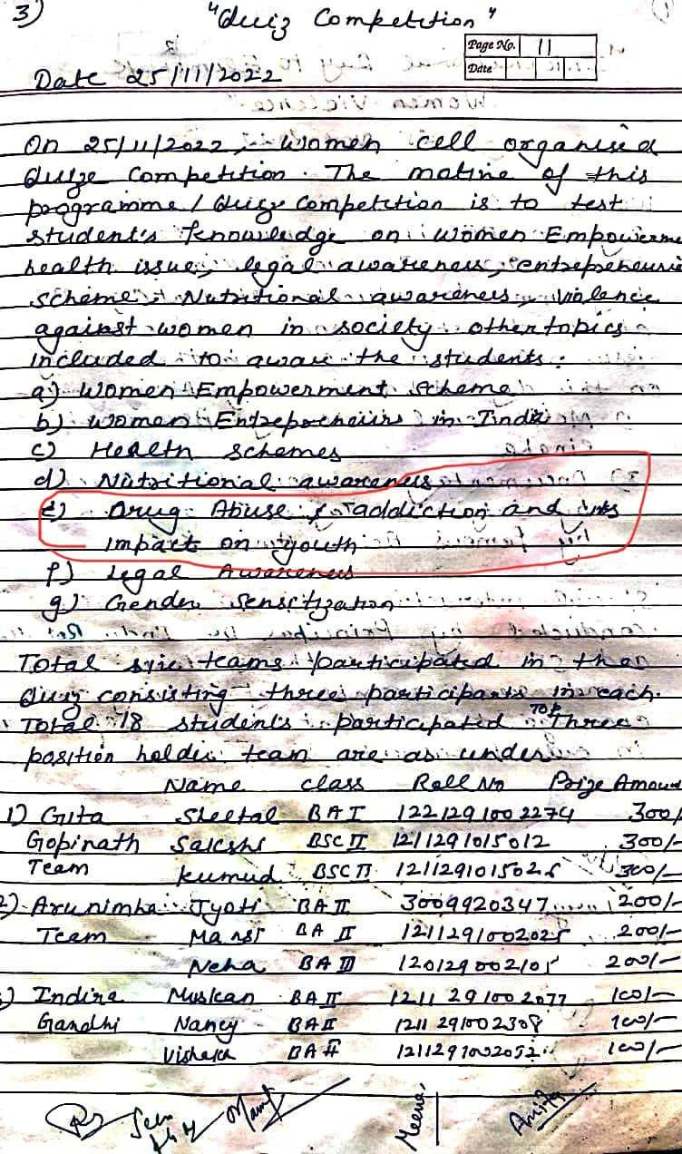

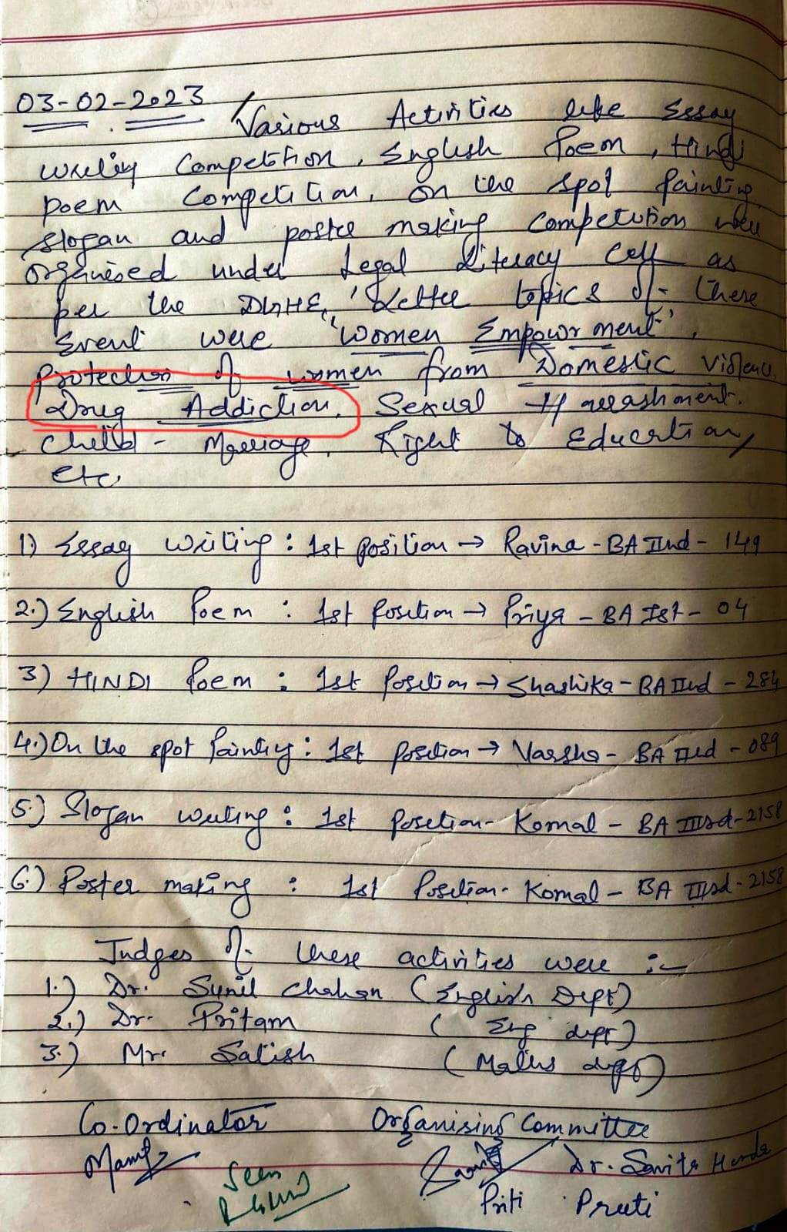

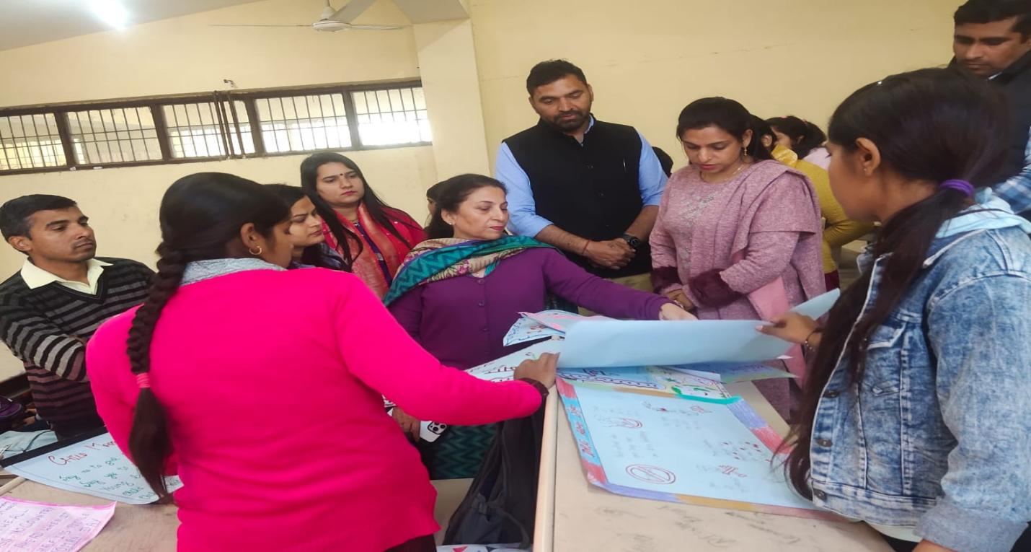

**Practice 2**

**Title of the practice:**A step towards making the surroundings clean

**Objective:To aware the masses about cleanliness of surroundings to promote good health.**

**Context:**The disease causing pathogens breed in dirty places. So, we can remain healthy if we keep our surroundings clean.

**Practice:The college is paving the way towards a clean and disease-freeIndia.**

**Evidence of success:NSS, NCC and YRC volunteers play a key role in this cleanliness drive by spreading the message of cleanliness in the society through rallies and camps.**

**Problems encountered and resources required:**

1. Lack of awareness about the impact of uncleanliness on the individual health.

2. Awareness programs may be organized in regular interval of time in well planned manner with the proper support of administration.

